

External Fetal Monitoring Software RFP
  - REQUEST FOR PROPOSAL

5/16/2024
Contents
Part I: Request 4
1.1 Project Summary 4
1.1.1 Current State 4
1.1.2 Future State 4
1.2 Requirements 4
1.2.1 CORE Capabilities 4
1.2.2 EXTENDED Capabilities 5
1.2.3 OPTIONAL Capabilities 5
1.2.4 AVAILABILITY Requirements 5
2.1 UnityPoint Health 6
2.1.1 About the Business 6
2.1.2 Technology 7
3.1 RFP Information 8
3.1.1 Contact Information 8
3.1.2 Submittal Requirements 8
3.1.3 RFP Schedule 8
3.1.4 RFP Evaluation Process 9
3.1.5 RFP Questions and Clarification Process 9
3.1.6 RFP Rejection of Submittals 9
3.1.7 Information Protection Vendor Survey 9
3.1.8 Non-Disclosure Statement 10
3.1.9 Business Associate Agreement (BAA) 10
3.1.10 RFP Vendor Finalist Selection 10
Part II – Response 11
1.1 Information Protection Security Survey 12
1.2 Response Summary 12
2.1 Engagement, Purchasing, and Delivery Model 13
2.1.1 Partner(s) Introduction and History 13
3.1 Solution Information 14
3.1.1 User Experience 14
3.1.2 Functionality 14
3.1.3 Solution Design 15
3.1.4 Hardware Requirements 16
3.1.5 Software and Licensing Requirements 16
3.1.6 Interoperability Requirements 17
3.1.7 Solution Security 18
3.1.8 Solution Support 18
4.1 Implementation Approach 20
5.1 Strategic Information 21
5.1.1 Architecture 21
5.1.2 Company Information and References 22
6.1 Pricing 25
6.1.1 Optional Pricing 25
7.1 Contractual Information 26
8.1 Response Agreement 28

Part I: Request

1.1 Project Summary
Electronic Fetal Monitoring (EFM) is a critical tool that helps to identify fetal distress during the labor process. Providers use EFM tracings to determine how a women’s labor and delivery process will be managed. Our current EFM technology is outdated. An upgrade to the current UPH Electronic Fetal Monitoring (EFM) system, will increase efficiencies for nurses and providers. Currently, most of our markets are utilizing PeriWatch. Our EFM system is due for an upgrade in the 2nd Qtr. 2025. Currently, there is technology available that provides more flexibility and functionality to support clinicians. These improvements will not only increase efficiency, but also support safe, quality care. New technology allows for increased flexibility and functionality for clinicians, including AI support, alarms that alert for dangerous fetal heart rates, and the ability to move between systems seamlessly so providers and staff can easily access information.

1.1.1 Current State
Our current EFM system provides basic monitoring. We can monitor fetal heart tracings and review multiple strips through central monitoring. However, there are many gaps in our current technology. Our largest gap is the lack of interface with Epic. Despite all our documentation being in Epic, the EFM strips are only viewable in PeriWatch. Additionally, all annotations can only be entered in PeriWatch. The lack of interface creates clinical and billing obstacles. There is a current workaround utilized for NST billing. Even with this workaround, significant additional time by providers and coders is needed to ensure all our NST’s are being billed properly. Our current system is utilized with wired and wireless monitors from various vendors. After a patient is discharged from Epic, it is very difficult to view an EFM strip. There are multiple requests for patients which require a nurse to spend a significant amount of time looking for EFM strips. Then these need to be printed and scanned into a PDF document to view. Currently, our providers have a multi-step process to access PeriWatch. Because of this, PeriWatch is rarely accessed remotely. In viewing the EFM tracings of twins and triplets, they can only be viewed together. This can create safety issues with the possible lack of clarity in which tracing is from which fetus.

1.1.2 Future State
The future state of our EFM system must include bi-directional interoperability with Epic. Epic will be the source of truth for ADT and all documentation, including vitals, annotations, and tracings. Clinicians will be able to view and annotate tracings, as well as bill NST’s within Epic. They will also be able to view strips in customizable time increments. Markets will continue to be able to utilize the vendors of choice for wired and wireless monitors. Searching for EFM strips of discharged patients will be done easily. Clinicians will have the ability to print, scan, or import tracings for a defined time period. The new system will provide real time alarms with bradycardia, tachycardia and tachysystole. The alarms will be customizable by the clinicians. Twin/triple tracings could be viewed together or separately. Providers will have easy remote access through an app. More AI support is desired, with the ability to customize alarms and pull relevant information to Epic, as well as automated checklists/algorithms, automated reporting, and early warning alerts.

1.2 Requirements

1.2.1 CORE Capabilities
The solution being recommended must provide the following services as part of the core offering:
R.1.1 | Epic will be source of truth for ADT and documentation (including ability to track patient changing rooms during process)  - Bi-directional interoperability (HL7, FHIR, etc.) for ADT, vitals, annotations, tracings, etc.  - Ability to view tracings within Epic; annotations viewable within the tracings  - Ability to view, annotate, and bill the NST within Epic
R.1.2 | Must have a modern interface and ease-of-use screen navigation
R.1.3 | Ability to view strips using customizable time increments (ie. 10, 15, 30 min)
R.1.4 | Ability to view multiple tracings simultaneously
R.1.5 | Ability to view multiple tracings concurrently with multiple workstations
R.1.6 | Compatibility with existing fetal monitors (see Exhibit A for current inventory):  - Wired models  - Wireless models  - Recording and viewing capabilities both on and off unit (patient in motion, E.D., et al.)
R.1.7 | Easy-to-use archive and search tools to access prior tracings
R.1.8 | Ability to print, scan, and/or import prior tracings in a defined timeframe
R.1.9 | Must have real-time alerts with ability to modify the control ranges (ie. threshold alerts for bradycardia/tachycardia and tachysystole)
R.1.10 | Ability to perform centralized surveillance
R.1.11 | Ability to perform patient remote surveillance with upload capability (ie. patient in ICU with portable monitor)
R.1.12 | Ability to move strips from one patient to another in the event fetal monitoring is recorded on the wrong patient
R.1.13 | Ability to view tracings without remaining logged in
R.1.14 | Ability to assign role-based security

1.2.2 EXTENDED Capabilities
These features are required but may be completed by using workarounds or other functionality within the solution. Third-party solutions may also be used to meet the criteria.
A.1.1 | Ability to view using mobile device app/browser
A.1.2 | Options for 24x7x365 customer support
A.1.3 | Ability to "hide" one twin's monitor tracing when interpreting, so each strip can be reviewed individually.
A.1.4 | Ability to modify and control parameters for clinical decision tools set at global or patient level
A.1.5 | Remote access capabilities for providers
A.1.6 | Ability to perform patient remote surveillance real time with connectivity to server when no port is available

1.2.3 OPTIONAL Capabilities
The capabilities listed below are not considered mandatory, but features deemed useful.
O.1.1 | Contain clinical decision tools including, but not limited to: AI early warning, automated checklists/algorithms, automated reporting and analytics, risk reduction, automated MVU calculations, etc.  - Note: If this feature is available, it must include configurable warning parameters.
O.1.2 | Telehealth capabilities (remote antenatal testing)

1.2.4 AVAILABILITY Requirements
- Solution availability: 99.99% uptime
- Recovery time: To be determined by solution
- Tolerated data loss: To be determined by solution
- Expected maintenance window: Once per month, off-prime business hours
Our expectation is that the solution is offline only to be able to execute patches, and even then for very short durations. Depending on the deployment type, it is likely a redundant system will be established to minimize any outage.

2.1 UnityPoint Health

2.1.1 About the Business
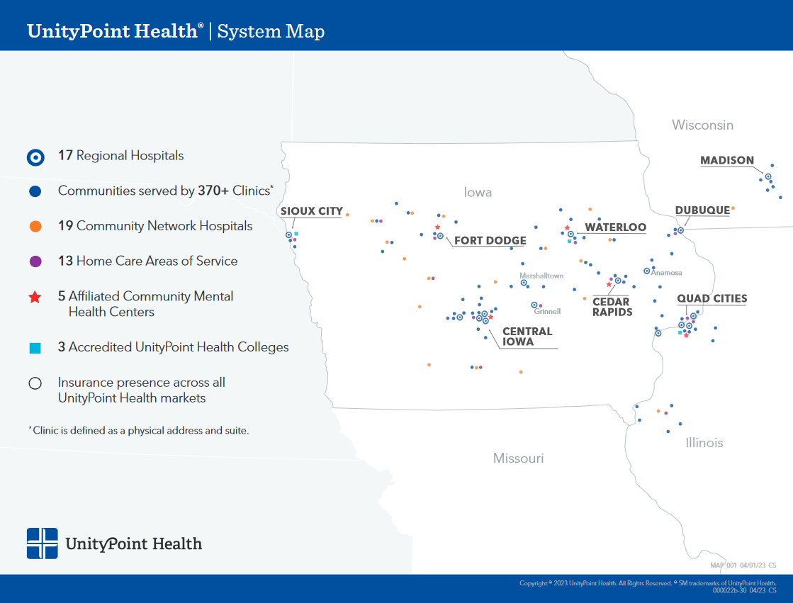

2.1.2 Technology
Category | Description
Electronic Medical Record System (EMR) | Epic Hyperspace, version Feb2024, is the primary record keeping system.
Data Centers | Two data centers are in use. The primary data center is in Hiawatha, IA, with a secondary facility located in Waukee, IA.
Server Virtualization Technology | UnityPoint Health is standardized on VMware’s ESX 8.x platform with vCenter managing the virtual server farms.
Server Operating Systems | The current standard for deployment is Microsoft Windows 2019. There is a smaller footprint of previous versions of Windows as well as IBM AIX and Linux.
Authentication | Microsoft Active Directory is the principal means of authentication. The current forest level is 2016.
Storage | Three tiers of storage are accessible using a multi-vendor approach. The storage is presented through IBM SVC controllers.
Networking | Wired connections in the major hospital facilities is 100mb and up to 1GB. Wireless connections support 802.11 a/b/g/n in all facilities. Data centers have up to 40GB connections with 10GB links to hospitals. Internet service is provided via two, 3GB redundant links.
Application Virtualization | UnityPoint Health utilizes Flexera Admin Studio for application packaging and Citrix XenApp/XenDesktop v.7.x for application delivery.
Database Technology | Microsoft SQL 2019 is the current standard with previous versions supported on a limited basis. A SQL Enterprise cluster environment is deployed within the data centers.
Desktop Standards | All approved desktops run Windows 10, 64-Bit with 16GB of RAM minimum. Office 365 is the current productivity suite.
Backup | Two primary mechanisms for backup are currently deployed: Avamar and SAN data replication. There is a limited deployment of VEEAM still in use as well.
Monitoring | SolarWinds monitoring suite and Microsoft SCOM provide the bulk of the infrastructure monitoring capability within the enterprise.
Interface Engine | CorePoint Integration Engine provides all key interface needs for financial and health record keeping systems.
Service Desk | ServiceNow is the help desk tool and plans are underway to expand its uses to include CMDB and discovery functions.

3.1 RFP Information

3.1.1 Contact Information
- Project Manager: Denny Warrick
  - E-mail address: denny.warrick@unitypoint.org
- Contract/Sourcing Manager: K.C. Coleman
  - E-Mail address: kevin.coleman@unitypoint.org
Please direct any questions or concerns to the individual(s) listed above. A question-and-answer session may be held to address any clarifications needed and will be listed in the RFP Schedule (section 3.1.3). Contacting other staff either on the project or within the organization with questions regarding the project are grounds for disqualification.

3.1.2 Submittal Requirements
All responses MUST be submitted via e-mail to individual(s) listed above. Please send the response as a PDF or compressed folder of files under 15MB in total size. It may be beneficial to follow-up submission with a call or separate e-mail to ensure delivery of the documentation.
The following documents are required as part of the review process:
- A completed RFP response document (Part II of this document)
- Base pricing and TCO spreadsheet
- Business Associate Agreement (BAA)
Vendors selected as finalists will also be required to complete an Information Protection Survey. This document is made available once finalists are announced.
All material submitted becomes property of UnityPoint Health and will not be returned. All proprietary information provided must be marked clearly as confidential and will be treated as such.

3.1.3 RFP Schedule
The planned RFP process is listed below. Please review the dates and confirm that you are able to meet the planned timeline.
RFP Process | Tentative Due Dates
Issue RFP | 5/16/2024
RFP questions due | 5/24/2024, 3p, CT
RFP Q&A – UPH response | 6/4/2024
RFP response due | 6/14/2024, 3p, CT
RFP response evaluation | 6/14/24 - 7/8/24
Vendor finalist notification | 7/9/2024
Vendor demonstrations | 7/22/24 – 8/9/24
Information Protection Vendor Security Survey Process | 8/30/2024
Reference calls | 8/14/24 – 8/29/24
Vendor design / Pricing Clarification | 9/6/2024
Vendor Negotiations | 9/27/2024

3.1.4 RFP Evaluation Process
After submissions for consideration are received, UnityPoint Health will:
- Internally evaluate each solution and recommend vendors for demonstrations
- Engage in demonstrations and Q&A sessions as needed
- Request further information and conduct reference calls
- Rate each solution based upon the criteria listed in Section 1
- Conduct further negotiations and discussions as needed
- Submit a finalized project summary

3.1.5 RFP Questions and Clarification Process
UnityPoint Health is committed to a fair and transparent evaluation process. During the RFP response period, a contact e-mail list of interested parties will be developed based on the letters of intent received. Any communications including clarification, changes or additions will be communicated via that contact list. Respondents can send questions to the contact e-mail address defined in Section 1. The question(s) and associated response(s) will be forwarded using blind carbon copy to the entire e-mail list. Responses that require additional research will be forwarded to the e-mail list.

3.1.6 RFP Rejection of Submittals
UnityPoint Health reserves the right to reject any and all submittals and to waive irregularities and informalities in the submittal and evaluation process. This RFP does not obligate UnityPoint Health to pay any costs incurred by respondents in the preparation and submission of their qualifications. Furthermore, the RFP does not obligate UnityPoint Health to contract for any expressed or implied services.

3.1.7 Information Protection Vendor Survey
Vendor finalists must submit a completed Information Protection Vendor Survey, a separate process once the finalists are chosen. Failure to complete the survey may result in disqualification from the product selection process. UnityPoint does not sign NDAs for Information Protection surveys.

3.1.8 Non-Disclosure Statement
Firms submitting response should NOT assume their responses will remain confidential regardless of any statements regarding confidentiality in responses submitted. During the period of evaluating which responding firm is the most qualified firm with which UnityPoint Health may, at its option, decide to negotiate a contract, UnityPoint Health will attempt to maintain the confidentiality of responses to the extent permitted by law. Once a firm is selected, or if UnityPoint Health decides at any time, at its option, not to proceed with the process of negotiating a contract for services, proposals may no longer be assured of confidentiality.
Certain processes that disclose intellectual property may be conducted under a formal non-disclosure agreement (NDA) if needed.

3.1.9 Business Associate Agreement (BAA)
Firms creating, receiving, maintaining or transmitting PHI on our behalf must agree to UnityPoint Health’s BAA. If applicable, our BAA will be attached and you will be required to answer affirmatively to signing it.

3.1.10 RFP Vendor Finalist Selection
An objective evaluation of all information requested in the attachments will be conducted to determine the finalist vendors. Vendors selected may be asked to participate in additional demonstrations, question and answer meetings, and design/negotiation sessions. Vendors not selected as finalists will be notified and no further information regarding the process presented.

Part II – Response

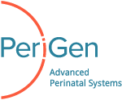

External Fetal Monitoring Software RFP
  - RFP Response

<Your Name, Title>
<Address>
<Phone number>
<E-mail address>

5/16/2024
Responses Due by Friday, 6/14/24 at 3:00 pm Central Time.

Information Protection Security Survey
If selected as a finalist, you are required to provide a completed Information Protection Security Survey. The project leader will make the form available once all documentation has been evaluated and finalists chosen. If the project leader has not provided the necessary documentation, please request the form.

Response Summary
The summary should present an overview of all major points detailed in the proposal and should be written in a manner that can be easily reviewed by UnityPoint Health management. Please include the following information:
- A brief summary of the proposal in non-technical terms. Include information regarding the background, experience, credentials and certifications required for this work.
- Overall scope of the proposed system(s) and services.
- Summary of available and in-development applicable product lines.
- Key differentiating points for your proposed solution.
- Summary of your company’s overall strategic direction related to the External Fetal Monitoring solution.
PeriGen’s proposal includes two applications that work in conjunction, PeriWatch Surveillance and PeriWatch Vigilance. Additionally, there are other modules that will be added to the suite that PeriGen has developed such as Cold Feed, DASx86, Labor Watch and Mobile. PeriGen offers 24/7/365 support to all clients.

PeriWatch Surveillance is our EFM and EMR documentation application. Surveillance via our custom configured Rhapsody Interface Engine, is validated for bi-directional interfacing with Epic systems. Rhapsody Interface Engines are configured to send messages using the HL7v2 standard. Currently PeriGen is developing/validating our applications to send messages with Rhapsody Interfacing using the FHIR standard. Tracings and all annotations interfaced to Surveillance can be exported as a singular file to be viewable within Epic. PeriGen refers to this product as “Cold Feed” and sends the files upon discharge.

Surveillance can display multiple tracings on a single screen. Some clients choose to dedicate a large monitor/TV to display all active tracings simultaneously. This view is possible when logged in or not. The amount varies depending on the monitor size. Tracing strips are viewable in 6,9 and 19-minute intervals. Surveillance archived strip retrieval is made simple with the ability to search by Patient Name, Prior Patient Name, Discharge Date, Discharge Date Range, Date of Birth or Medical Record Number. Surveillance has the ability to print tracings. PeriGen’s DASx86 product can be installed on a PC attached to a fetal monitor for mobile EFM capabilities. If a strip is documented on an incorrect patient, Surveillance can transfer said strip to the correct patient. Surveillance can be configured with Active Directory integration for user accounts and Role based permissions are customized within the application.

PeriWatch Vigilance is our AI driven EFM early warning system. PeriWatch Mobile is a module that allows clients to view the application within a browser on a Cell Phone, Tablet or PC with a smaller monitor. Mobile can be configured to allow access from outside the organization as well, if desired. Vigilance’s single patient view is capable of displaying twin tracings while viewing both tracings or a single tracing at a time. Labor Watch is an additional module that can be used to receive SMS notifications on alerting patients. Labor Watch is configurable to accommodate an escalation process of SMS notifications. Meaning, unacknowledged alerts or critical alerts can be directed to certain individuals.

2.1 Engagement, Purchasing, and Delivery Model
Please use this section to detail the recommended delivery model. If recommending an indirect model, please use section 2.1.1 to introduction the recommended partners.

PeriGen will engage with the client within 2 weeks of receiving a signed contract. At that time a PeriGen PM will contact the client and begin discussing the format for the weekly project calls.

During the initial Kick off meeting, the PeriGen PM will discuss needed resources and roles for the project. This will include the resources/roles needed from both PeriGen and the client. At the conclusion of the kickoff meeting, client should have Server specs and all pre-requisites needed to complete the project.
The weekly project calls will primarily serve as status updates and often will be when Go-Live date is discussed/confirmed. Additionally, meetings for ADT, EMR and tracing validation will be scheduled to ensure product/client readiness.
At the conclusion of validation, PeriGen and the client will begin preparation for and perform the Go-Live of Production systems.

2.1.1 Partner(s) Introduction and History
Please use this section to introduce the recommended partner(s).
<Insert partner information here. If no partners are needed, please delete this section.>

3.1 Solution Information

3.1.1 User Experience
Please use the space below to visually demonstrate the user and administrative experience of the proposed solution. Include notes on what is being demonstrated and how it pertains to overall usage of the solution. This should also include mobile device views vs. traditional workstation views.

User Experience
PeriWatch Surveillance
Surveillance Census board. This view shows a listing of all patients along with critical information during labor.
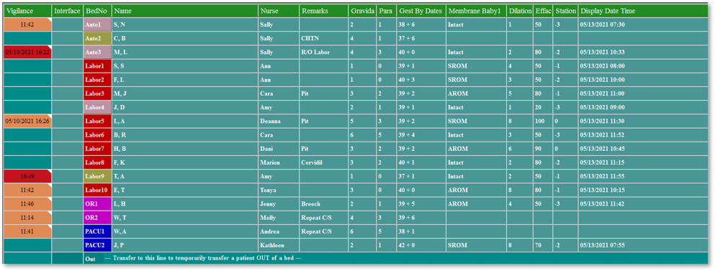
Documenting Customizable Annotations in Surveillance for a patient.
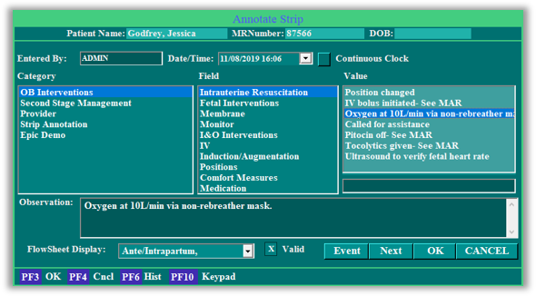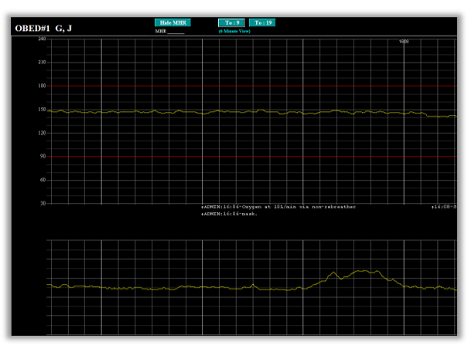
Documenting Fetal Assessment
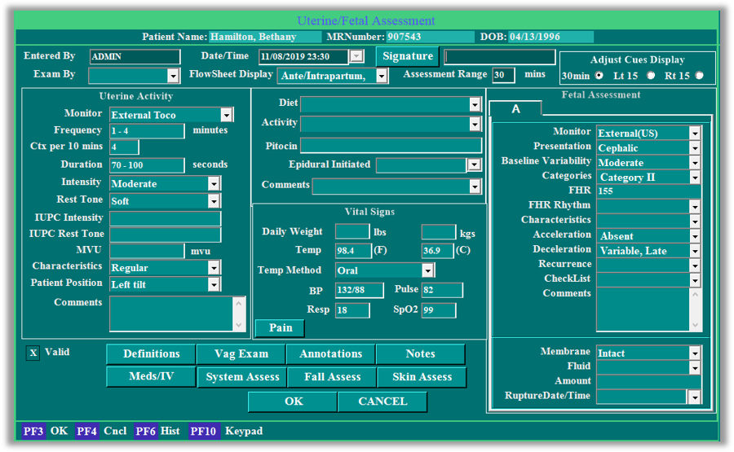
Documenting Cervical Exams
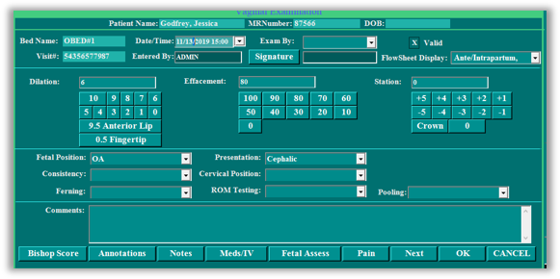
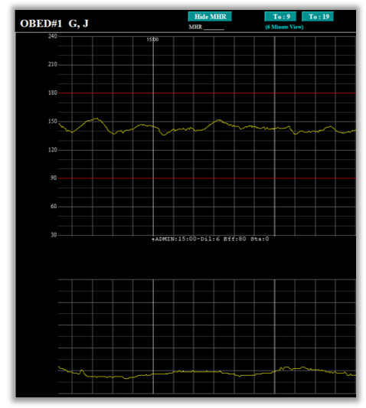
Modifying Threshold Alerts
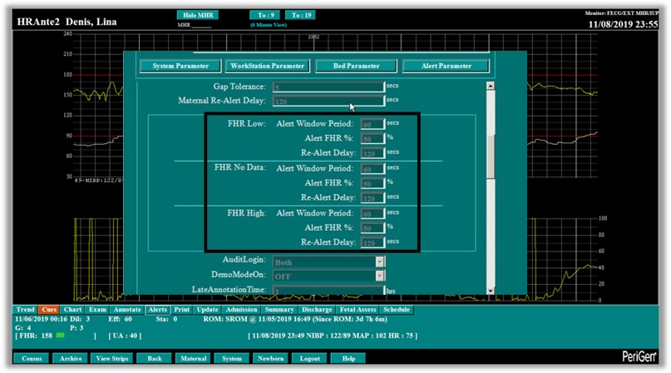
Tracing Archive Retrieval and Comparison
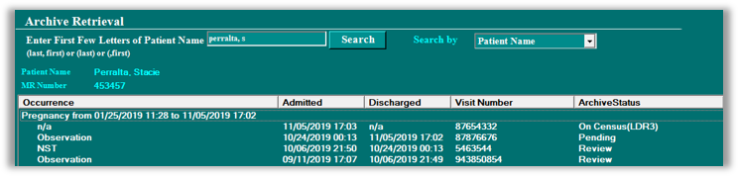
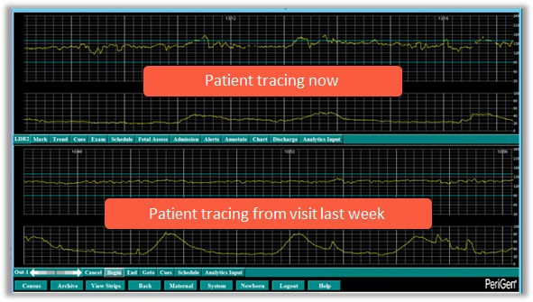
Documenting Admission
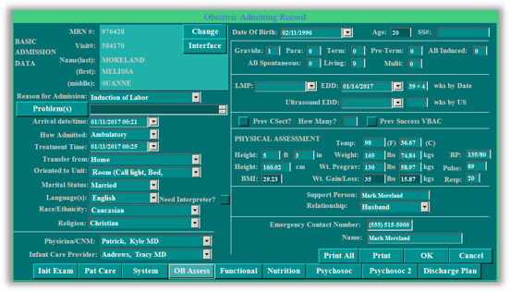
Documenting Labor and Delivery
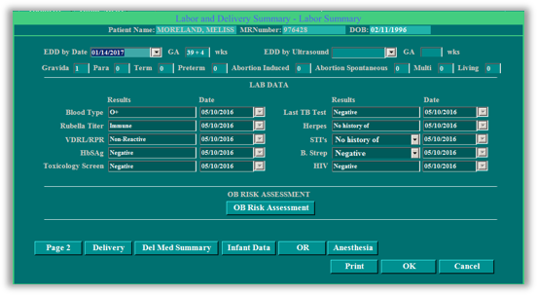
Labor and Delivery Hand Off
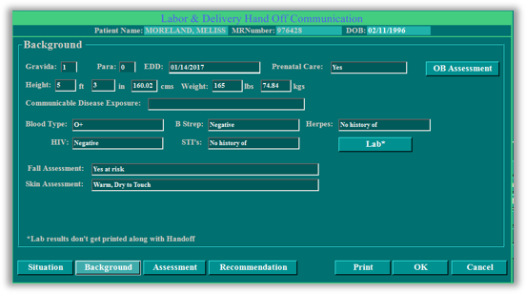
PeriWatch Vigilance
Mobile Vigilance View
Vigilance Hub View. This view show a listing of patients and their current status as well as other critical vitals.
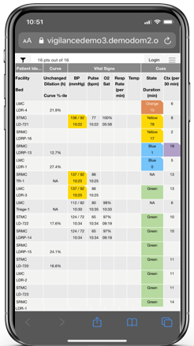
Single Patient View. This view shows a patient’s current tracings as well as Vigilance Cues, Labor Curve and Vital signs.
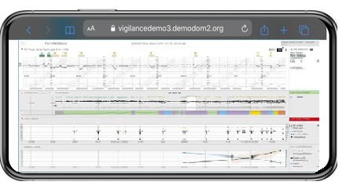
Desktop Vigilance View
Left Image – Hub View; Right Image – Single Patient View
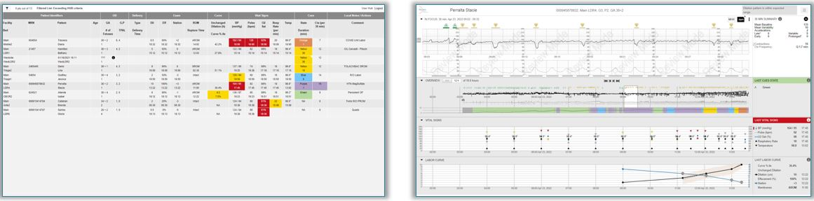

3.1.2 Functionality
Question | Vendor Response
Please describe the solution’s ease-of-use features.
Please describe any workflow process approval tools built into the system.
How is information recorded from monitors displayed? | Data from monitors is transferred to PeriWatch servers via DAS units, Network Redirectors and/or MOXAs. A conversion from serial to ethernet will take place prior to traversing to the PeriWatch server. After that, the tracings are stored and saved in the PeriWatch DB and displayed on the client side applications.
Please define how up-to-date the information displayed from monitors is? For example, data is real-time, 3 second delay, 5 second delay, etc. | Data is real time
What tools are available to customize device polling (receiving data from monitors)? | Configuration changes can be made by PeriGen Technical Services.
What tools are available to customize data intervals for display? For example, a user wishes to see time increments of 10 seconds. | Within the Surveillance and Vigilance applications, each user can choose their preferred in time increment.
How can the feeds be setup to create a centralized monitoring workstation? | By design, PeriWatch is capable of displaying a centralized monitoring workstation showing all active tracings for a given facility.
How does the solution support multiple machines all viewing the same monitors concurrently? | Each user is provided their own login and can access the application on a computer that has the Surveillance application installed or Vigilance via a browser. Within this view, any number of staff can view a single tracing or multiple tracings on multiple workstations concurrently.
What tools are available to “silence” or hide a tracing when looking at twins/multiples to allow individual assessment? | Within the Vigilance application, there are buttons in the top right corner that allow hiding Baby A or Baby B’s tracings.
How does the solution enable viewing monitors that are remotely connected but out of the unit? | With PeriGen’s DASx86 solution, a workstation can act as a DAS unit. The workstation will need to be plugged in to the Fetal Monitor via a PeriGen supplied USB dongle and capable of transmitting wirelessly or via ethernet to the PeriWatch server. If this workstation is configured in PeriWatch as a monitored location, the tracings will display on the board.
How does the solution enable corrections to be made? For instance, if the monitor is incorrectly noted to the wrong patient. | Tracings can be merged, cut or moved to another patient.
Please describe the retention and archive capabilities of the solution. | Surveillance and Vigilance have the capability of storing data infinitely. When Surveillance is the EFM of record, Cold Feed(described above) exports are available. Some customers choose to import Cold Feed documents into their HIM for record retention. Some choose to retain the records on a SAN.
What limits are placed on monitoring file sizes? For example, a file size limit of 2 MB before a new file is created.
What limits are place on file retention? For example, monitoring files may be retained for ten years. | PeriGen can work in conjunction with the client to clean out no longer needed medical records. No limits currently exists as this will depend on client infrastructure (disk space).
What tools are available to import printed scans into the solution? For instance, a remote (not connected) monitor printout from ICU?
How are users approved or restricted from being able to import data? | Only PeriGen Technical Services would have the capabilities to import data directly to the application. Other method would be SQL database access and that is restricted by client. PeriGen required DBO access after installation and all SQL access can be achieved with a service account.
Please describe the printing capabilities of the solution (including archived strips) | Printing is capable within the Surveillance application. This will print out the strip and any annotations that have been documented on it. After retrieving or reverse discharging a patient, you view their previous visit.
What tools does the solution have to print to file? | Only the one described previous with strips.
Please describe the search tools built into the solution. | Users are able to search for patients by Patient Name, Prior Patient Name, Discharge Date, Discharge Date Range, Date of Birth or Medical Record Number. PeriGen Technical services can also search for patients by other means as well.
How does the solution enable searching annotations?
How might multiple search return results be viewed simultaneously? For instance, a search of 01/01/2024 returned five tracings and a supervisor wishes to see all five side-by-side. | The supervisor could view all the tracings at once by retrieving the desired visits from Archive in the Surveillance application. At that time they will show up in an “Out” bed. The supervisor would then highlight the desired patient on the board and select View Strips. The trend button for each tracing would allow scrolling forward and back.
Please describe the alerting capabilities within the solution.
What methods are used to communicate alerts, on-screen, e-mail, et al.? | On-screen, SMS and audible alerts are all available.
How are alert thresholds customized? | Alert thresholds are customized within the Surveillance application. Screenshots above. Additional threshold configurations are available in Vigilance as well.
How are alerts snoozed or silenced? | An alert can be acknowledged(silenced) or ignored by clicking exit(snooze).
Please describe the reporting and analytic capabilities of the solution. | Both Surveillance and Vigilance offer many reports. SQL SSRS is used to collect the data from the applications and display them via HTTPS. These reports are also able to be emailed on a scheduled run time.
How are reports or dashboards customized for the user? | Reports can be customized upon request.
How does the solution enable trend analysis?
What other clinical decision/forecasting capabilities exist within the solution?
Please describe the auditing capabilities within the solution. | Surveillance and Vigilance both log all user activity within the application.
How are actions like changes to tracing assignment, data imports, or printing tracked and reported? | All actions are logged in the SQL database with items such as username, date, time and action taken. No reporting on these items currently exist.

3.1.3 Solution Design
In the space below, please provide a Visio diagrams representing the underlying infrastructure and data flows of the solution. Include a detailed explanation of how this design meets the availability requirements detailed in Part 1, Section 1.2.5.

This diagram illustrates the typical set up model but the proposed DR/HA solutions are described in this document.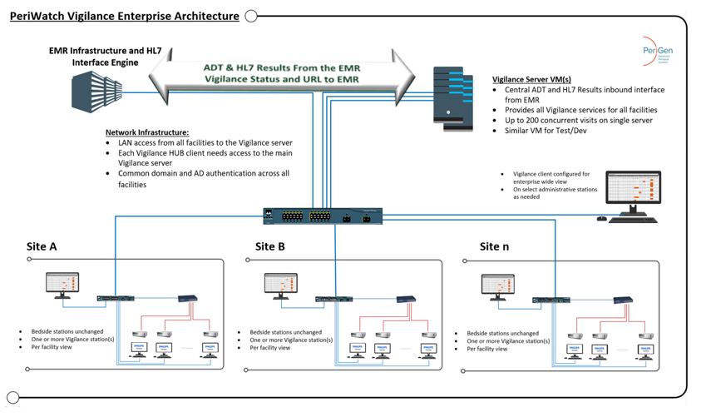3.1.4 Hardware Requirements
Question | Vendor Response
If the solution is solely being presented as remotely hosted or Software-as-a-Service (SaaS), please mark inapplicable questions as “N/A”.
Please provide any hardware specifications needed to support the solution. Break down RAM, CPU, and disk requirements into required and recommended groups. | Specifications depend on a few factors with the most important being monitored locations. I have placed a screenshot below for recommended specifications based on monitored locations. Required specs will depend on the amount of monitored locations, workstations and network connectivity/reliability. 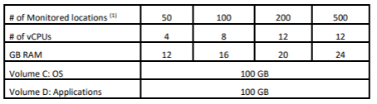
Please provide recommendations for hardware fault tolerance.
If a recommended solution includes optionally breaking apart the solution into functional servers, e.g., separate SQL and application servers, please provide usage specifications and hardware requirements. | Dedicated SQL Server Specs  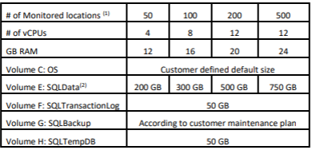  Dedicated Rhapsody Engine *(RAID1 is only if using physical servers and not VM)  Small Site  Site Assumptions  • The site receives less than 300,000 messages per day.  • Each message requires mapping from one format to another and performs a simple table lookup  before forwarding the message to another 10 systems.  • Peak load is about four times the sustained rate.  Minimum Hardware Recommendations  • Windows Server or Linux.  • 64-bit Operating System.  • 4 cores.  • 8GB RAM and 2GB heap.  • 40GB disk space for OS and applications (RAID1)*.  • 200GB disk space for datastore (RAID1)*.  Medium Site  Site Assumptions  • The site receives between 300,000 and 3,000,000 messages per day.  • Each message requires mapping from one format to another and performs a simple table lookup  before forwarding the message to another 10 systems.  • Peak load is about four times the sustained rate.  Minimum Hardware Recommendations  • Windows Server or Linux.  • 64-bit Operating System.  • 8 cores.  • 8GB RAM and 4GB heap.  • 40GB disk space for OS and applications (RAID1)*.  • 500GB disk space for datastore (RAID1)*.  Large Site  Site Assumptions  • The site receives more than 3,000,000 messages per day.  • Each message requires mapping from one format to another and performs a simple table lookup  before forwarding the message to another 10 systems.  • Peak load is about four times the sustained rate.  Minimum Hardware Recommendations  • Windows Server or Linux.  • 64-bit Operating System.  • 8 cores.  • 16GB RAM and 8GB heap.  • 40GB disk space for OS and applications (RAID1)*.  • 1TB disk space for datastore (RAID1)*.
What server virtualization technologies are supported? | PeriGen can work with VmWare, Nutanix, Dell HCI and Citrix.
What are the minimum SAN IOPS required to support the solution?
What is the mean time between failures (MTBF) for all the hardware being proposed?
What are the network requirements for supporting the solution from both a server and end-point perspective? | A 1000Mb uplink for the server and a RTT of under 40ms is preferred between client and server.
What is the maximum amount of network latency that the solution tolerates? | RTT of 40ms or less between client and server.
How does your solution support wireless fetal monitors? | PeriGen has a DASx86 solution that will send the data to the server via a workstation plugged in to the fetal monitor.
What type of wireless technology would be required? | 802.11 ac/b/g/n and newer are all acceptable solutions.

3.1.5 Software and Licensing Requirements
Question | Vendor Response
If the solution is solely being presented as remotely hosted or Software-as-a-Service (SaaS), please mark inapplicable questions as “N/A”.
Please describe the solution’s software architecture. | The application is built on ASP .NET framework. It utilizes IIS to handle web calls and displays. SQL is used for data storage and Lyniate Rhapsody is the interface engine.
Please provide recommendations for creating a highly available application environment. | The current recommended solution is V-Motion or similar for the application server and to house the SQL data on a cluster. Another recommended solution is to copy the current application server to another datacenter as a standby. In the event of a DR situation, the secondary server would become active and handle all communication.
Please describe your licensing models.
How are additional licenses procured and added?
How is a typical “True-up” licensing event handled, if applicable?
Please describe any assurance offerings such as support, maintenance, patching, upgrades, etc.. | PeriGen offers 24/7/365 support, free upgrades and patching.
If Windows Server is required, what version is currently supported? | Current applications are available on Windows Server 2016, 2019 and 2022 Standard Edition or higher.
Does the solution require SQL? If so, please detail the version supported and the recommended configuration. | Yes, SQL is required. Specification information provided above. Detailed information on the required set up is attached (Lab00003)
What application virtualization technologies are supported? Please describe any best practices directly relating to virtual application packing and delivery. | Outside of the technologies described above, VDI solutions for workstations are also supported.
What underlying software technologies are required? If something like Internet Explorer or Java is required, please detail the versions that are supported. | - .NET version 4.8  - IIS 10.x (OS 2016/2019/2022)  - Web Browser Requirements:  - IE version 11 (Minimum). Compatibility mode is not supported.  - Edge browser.  - Google Chrome as the preferred browser for the Vigilance system.  - MS SQL 2016 Standard Edition / MS SQL 2019 Standard Edition / MS SQL 2022 Standard Edition  - .NET 8.0.1 Windows Hosting  - Note that version 8.0.1 is the version required for correct functionality of Vigilance.  - VC++ 2013 & VC++ 2015-2022 Redistributable (self-install by the installation wizard)  - PowerShell version 5 or higher
What browsers (workstation and mobile) are supported? | Workstations:  - IE version 11 (Minimum). Compatibility mode is not supported.  - Edge browser.  - Google Chrome as the preferred browser for the Vigilance system.  Mobile:  - Edge browser.  - Google Chrome as the preferred browser for the Vigilance system.  - Safari
Is an app available through the Google Play Store or Apple Store available? | No app is required
How many environments does the software independently support? For example, is a development, test, and production environment configuration available? Is additional licensing required? | Yes, all 3 options are available but my incur additional costs. Typical deployments consist of a Test and Prod environment.
What application monitoring probes are available? | PeriGen recommends using resource monitoring solutions to capture CPU, RAM and disk space thresholds being met.

3.1.6 Interoperability Requirements
Question | Vendor Response
Please list the devices (wired and wireless) the monitoring solution supports. | 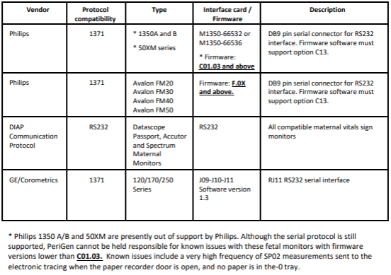
For unsupported devices, how might data be imported?
What paths are available to get currently unsupported monitoring devices approved or integrated?
What interface engines, if any, are supported for creating data transmits? | Lyniate Rhapsody is required on the PeriGen side. As for the client side, we just require an HL7 message be sent.
What interface languages, like an API or HL7, does the solution support? | HL7v2
If applicable, please append a copy of the technical details of the solution API structure.
Please describe the solution’s ability to integrate bi-directionally with Epic. | Please see the attached document (LAB000916) for interface specification and common interfaced data. Other data may be capable of being interfaced depending on the request.
How many successful Epic integrations have been completed to date?
How does the solution capture monitor data for telehealth solutions? | Currently in-development PeriGen is working on a solution to provide NST and remote (from-home) monitoring capabilities.

3.1.7 Solution Security
Question | Vendor Response
How are users created within the solution? | Typical set up includes PeriGen receiving an AD group name to be used per for user access. Multiple groups can be used to accommodate multiple facilities.
What levels of security are available? | Role based authentication is configured within the application.
How is user security maintained? | User AD group membership will determine access, along with AD account status.
What level of encryption, if any, is in use? Please describe if information is encrypted in-motion or at-rest including specific encryption mechanisms. | SQL data encryption is available upon request. All web requests from clients are via HTTPS over TLS.
What authentication methods are needed or supported? For instance, does the application rely on Active Directory authentication for user setup and security? | Active Directory is recommended but local user accounts are also an option.
How does the solution support security procedures such as multi-factor authentication? | Imprivata is a supported solution. Other solutions would require a discussion with PeriGen Technical Services.
What mechanisms are in place to audit user activity and administrative activity? | All user and admin activity are logged in to the SQL database. PeriGen Support can provide the logs.
What identity management systems, if any, does the solution integrate with?

3.1.8 Solution Support
Question | Vendor Response
If the solution is solely being presented as remotely hosted or Software-as-a-Service (SaaS), please mark inapplicable questions as “N/A”.
Provide details of available support options. | 24/7/365 support is offered by PeriGen.
Please provide copies of any relevant Service Level Agreements (SLA) and Operational Level Agreements (OLA).
Would support come directly the company or a third party? | Directly from PeriGen
How are issues like application performance addressed? | PeriGen support should be contacted and if needed escalations by PeriGen will take place.
If the solution is SaaS, please describe support metrics for resolution. How many issues are resolved upon first contact? | N/A
If the solution is hosted or SaaS, how does support staff notify the customer of issues and unplanned outages? | N/A
What is the guaranteed response time for solution support? Describe any prioritization and escalation procedures. | Support is reachable by phone 24/7/365 an guarantees 3 hour response time for critical issues.
What priority levels are assigned to issues brought by users? | Priority levels are assigned based on incident. For instance System Outage will guarantee immediate support while a user being unable to log in would receive a lower priority. Most issues are prioritized based upon impact to the customer.
If the solution is hosted or SaaS, please describe the disaster recovery and high availability capabilities built around it. | N/A
How many people make up the support staff for this solution?
What tools are available for self-support, e.g., a web-based knowledge portal? | PeriGen has many documents and videos that are available.
What user communities are available for peer-level product support?
What are the standard hours of support? | 24/7/365
What options are available for having 24x7x365 support?
What structure do you recommend customers create for internal support? | PeriGen recommends that during the project life cycle these items be discussed. Depending on the organization, certain models may not fit.
If a SaaS solution, please describe the support model for user issue escalation. One example would be issues funneled through an internal point person, then to vendor’s support teams. | N/A
If UnityPoint Health required a dedicated troubleshooting session, what resources would be expected to participate? What expenses may be incurred beyond standard support fees? | Depending upon the issue, Network, Systems, InfoSec, Desktop, Informatics Specialist, Interface Specialist and/or BioMed Technician may be required. Almost all support issues are handled without a cost associated.
What reports are available within the solution or service to detail the requested support requests? | PeriGen can provide a report of all cases that have been created for the client upon request.
Please provide any warranty information.
Are bug fix notifications available on the solution website? Are security fix notifications available? How are customers notified? | Bug/fix notifications will be emailed to relevant clients when they are available.
Does an upgrade or maintenance patch require an outage? | Upgrades require an outage, some patches do not require an outage.
What tools or infrastructure setups are recommended to limit application outages during patching? | Patches usually take minimal time to complete. Most completing well under an hour.
Are new application updates implemented immediately? If no, how soon after a new release is delivered will UnityPoint be required to implement the upgrade (i.e., how many releases can UnityPoint fall behind without losing support or being forced to update? | No, updates are completed on an as-needed basis or when the customer decides to upgrade. PeriWatch versions are typically supported until the validated Windows Server versions are no longer supported. For instance, Surveillance 2020 is validated against Windows Server 2012 and 2016. When Windows Server 2016 is no longer supported, PeriGen will sunset support for Surveillance 2020 soon after as well.
Will UnityPoint be required to accept all changes delivered in new releases, if it does not need or want to change? | Depending on the change, modifications may be able to be accommodated.

4.1 Implementation Approach
Question | Vendor Response
Describe a typical approach to implementing the solution at an organization of UnityPoint Health’s size and complexity. Please factor in the requirement to implement the solution at several hospitals of varying sizes, across a wide geographic range. | Depending upon the location of Datacenters and network reliability, one or many instances of the application may be set up by region to accommodate.
Please describe the phases of a typical implementation. | Typical implementation will consist of the below:  Kickoff/Discovery  Test Environment Build  Test Build Validation  Production Build  Production Go-Live  Transition to Support
Provide a sample implementation work plan for the proposed solution indicating the tasks required, the relative sequence of tasks, the party responsible for each task, and the approximate time to complete each task.
If this is not indicated in the work plan from the previous question, please describe the staffing approach for this implementation. Discuss the type and number of staff assigned for what duration with each. (Please ensure these numbers reflected in the Base Pricing.xls attachment)
Please discuss and provide examples of tactics to enable expedited implementations. | PeriGen Key Account Managers and Project Managers are always looking for ways to expedite implementations. Weekly meetings help to facilitate communication along with detailed agendas and meeting notes that follow every meeting. All agenda items detail discussions made during the sessions and any emails that may have come across in between time.  PeriGen also engages multiple technical resources throughout the project lifecycle to expedite or keep the project moving should something arise.
What options are available for user training before the solution is live? What options are available for user training after? | Clinical staff training is available and usually takes place between 1 month and 2 weeks prior to Go-Live. Our Clinical Leads are also on-site during Go-Live and offer 1:1 or small group sessions throughout the day as well.
What options are available for super-user and administrative training? | Super-User and Administrative training is also available is the same manner as just described.
What quality control mechanisms are used to ensure proper testing of the solution before UnityPoint would take it live? This may include load testing, proof-of-concept, piloting, and other known testing methodologies.
How much time is UnityPoint Health expected to dedicate to the implementation of the solution? Please provide an estimate of FTE hours.
How much time is support staff, UnityPoint Health or vendor, expected to spend on maintenance and support? Please provide an estimate of FTE hours.

5.1 Strategic Information

5.1.1 Architecture
Question | Vendor Response
Please identify the number of unique customers using the most recent version of the solution.
What options are available for engaging in roadmap sessions to capture vendor future directions?
What is the greatest strength of the solution?
What areas are being focused on for solution improvement and growth?
Are any customer or professional groups involved in the direction of the solution? If yes, is UnityPoint Health able to participate in product change suggestions?
If the solution presented is hosted or SaaS, where is the hosting location or what is the service? How long has the application been hosted in this location? | N/A
What improvements are expected in the next full version of the solution? What about improvements in the next maintenance release?
What infrastructure changes are typically needed with a full version upgrade? | Typically, changes are reduced to OS upgrades and pre-requisite software updates.
What is the typical schedule for releasing patches and maintenance upgrades?
What is the typical schedule for full version upgrade releases?
If both an on-premises and hosted version of the application are available, does development occur equally for both versions? If no, please detail the differences between versions. | N/A
How long after the release of a new OS does it typically take before the solution supports the upgrade?
What, if any, services are available to review the deployment of the application and investigate unused features of the product?
What services are available to demonstrate upcoming version features of the software to UnityPoint Health personnel?
What services are available to help recruit and identify administrative and super-user staff from outside UnityPoint Health?
If the application or service is determined to no longer meet the needs of UnityPoint Health or is being discontinued, how is data made available? | All data within the PeriGen application can be exported to the client and/or SQL databases can remain active while the application is uninstalled.

5.1.2 Company Information and References
Question | Vendor Response
Identify the locations (city, state) of the following:  Corporate Headquarters:  Programming/Technical Support Personnel:  Consulting Services Personnel: | HQ: Cary, NC  Programming/Tech Support: Cary, NC  Consultants: N/A
Please indicate under the laws of which state is the vendor is incorporated:
What is the number of employees in your organization, categorized by:
Total:
Management/Sales:
Research and Development:
Installation:
Is the company or division currently for sale, or involved in any transaction(s) to acquire, to be acquired, or to merge with another organization? If yes, please provide detail.
Has the company been involved in any name change reorganization, acquisition or merger within the past 3 years? If yes, please provide detail.
Has the company, or any firm with or under a controlling interest, ever filed for bankruptcy?
Is the company a subsidiary of or under the control of any other corporation, individual, or other entity? If yes, please provide name.
Please provide the last three years of fiscal information for the company, including annual revenue, net profit, total debt, and total assets.
How many years’ experience does the company have in providing products and services equivalent or related to those called for in this RFP?
What percentage of business involves products and services equivalent or related to those called for in this RFP?
What percentage of revenue is spent on Research and Development?
What is the company’s key competitive advantage?
Describe any involvement your company currently has with organizations that are helping to set national IT standards.
Briefly describe the company’s vision of the future for the healthcare industry.
Briefly describe the corporate vision for healthcare technology, specifically addressing your strategic vision for how information technology will support the healthcare environment of the future (i.e. the integration of financial systems with patient care).
Please provide the following information for customer references. UnityPoint will not contact any references without the vendor’s permission. If possible, it is important that to include references that are similar to UnityPoint in terms of size, using the recommended partners, and preferably within the healthcare industry.
Customer Reference #1
- Organization Name:
- Organization Address:
- Size and Type of Facility (number of hospitals/beds, employees, revenues):
- Name and Release Version of Solution Installed:
- Solution Live-dates:
- Previous System Environment:
- Nature of Relationship between vendor and reference site (i.e., partner, beta site):
- Individual who will have sufficient experience to speak knowledgeably concerning such issues as the implementation process, product functionality, vendor support, and documentation and training.
  - Name
  - Title
  - E-Mail Address
  - Phone Number
Customer Reference #2
- Organization Name:
- Organization Address:
- Size and Type of Facility (number of hospitals/beds, employees, revenues):
- Name and Release Version of Solution Installed:
- Solution Live-dates:
- Previous System Environment:
- Nature of Relationship between vendor and reference site (i.e., partner, beta site):
- Individual who will have sufficient experience to speak knowledgeably concerning such issues as the implementation process, product functionality, vendor support, and documentation and training.
  - Name
  - Title
  - E-Mail Address
  - Phone Number
Customer Reference #3
- Organization Name:
- Organization Address:
- Size and Type of Facility (number of hospitals/beds, employees, revenues):
- Name and Release Version of Solution Installed:
- Solution Live-dates:
- Previous System Environment:
- Nature of Relationship between vendor and reference site (i.e., partner, beta site):
- Individual who will have sufficient experience to speak knowledgeably concerning such issues as the implementation process, product functionality, vendor support, and documentation and training.
- Name
- Title
- E-Mail Address
- Phone Number

6.1 Pricing
Solution costs are requested as part of the competitive process. Please be reasonable when completing the cost documentation; do not under-bid or over-bid. Proposed costs will be compared to proposals for institutions like UnityPoint Health, as well as actual costs incurred by comparable organizations, determined by surveying industry sources and contract negotiation services.
The proposal must clearly define ALL costs expected to be incurred by UnityPoint during implementation and throughout the term of the contract. Please use the attachment Base Pricing-TCO.xlsx to capture the costs including the following items:
- One-time costs;
- Implementation or installation costs;
- Reoccurring costs over a ten-year period;
- Training costs (if applicable);
- Maintenance and upgrade costs (as applicable);
- The ten-year expected costs.
Costs for each component and service should be broken down by installation (one-time) and ongoing expenses. If on-premises and hosted versions of the application are available, please detail costs for both instances.
It is essential that cost data be provided in a format that enables comparisons between vendors. For this reason, vendors may supplement the requested information, but the format requested is required at a minimum. Please fill out all sections in the attached base pricing spreadsheet in the format requested. Specify the method used to calculate costs. List software costs by system or solution. If the software is compatible with multiple hardware platforms, please propose a recommended platform for the UnityPoint environment.

6.1.1 Optional Pricing
UnityPoint Health would like to have made available a list of components, features, and a la carte options with pricing.
Please include all optional costs on the Optional Components tab within the BasePricing-TCO spreadsheet.

7.1 Contractual Information
Indicate, in the following table, your agreement to the contractual requirements identified. If you cannot agree to these requirements, explicitly state such in your response and provide alternative contract language for consideration.

Requirement | Yes | No | Comments
- Should UnityPoint contract with your organization, there are no pending litigation activities involving your organization that could have an impact on UnityPoint.
- The vendor will contract guaranteed prices for software systems that are currently under development and not yet installed.
- The vendor will contract for “not to exceed” installation fees.
- Is UnityPoint required to purchase all recommended hardware with you, or may it procure directly from hardware vendors?
- Is UnityPoint required to purchase all recommended third-party software with you, or may it procure directly from those vendors?
- The vendor will stipulate that the contract will be entered into, under, and governed by, the laws of Iowa.
- The vendor will agree to unconditionally guarantee all items bid upon against defects in materials, workmanship, and performance for one year from date of installation by UnityPoint unless otherwise specified.
- If applicable(and attached), the vendor has reviewed UnityPoint’s BAA and agrees to all terms within it, without changes, and will agree to sign it if UnityPoint moves forward to contracting with vendor.
- Proposed acquisition and ongoing maintenance or support costs include any future enhancements or upgrades to the system/solutions. If not, indicate additional costs in the cost quotation.
- Proposed acquisition and ongoing maintenance or support costs include licenses for operating system and related environmental software. If not, identify any additional component costs in the cost quotation.
- If vendor releases new software designed to replace the proposed solutions, the following provisions will apply:
  - Within four (4) years of execution of this contract, vendor will provide new software with no additional license purchase price or implementation, support, and training expense to UnityPoint.
  - Past initial four (4) years but within seven (7) years of the execution of this contract, vendor will provide new software at the current license purchase price less a 60% discount and provide for a 60% discount regarding implementation, support, and training expenses.

- Please provide a copy of your standard contract for customers similar in scope to UnityPoint.
- How many contracts have you signed in the last three years?
- How many of those sites have completed implementation of your system?
- Describe your formal procedure for system acceptance, including hardware and software.
- Have any of your customers cancelled a contract in the last two years before, during, or after an installation? If yes, why? (Specify organization and location.)

8.1 Response Agreement
Response Agreement
In consideration of this response to the Request for Proposal from UnityPoint Health (UnityPoint),

(Name of corporation)
Agrees that:
- The vendor response will become the property of UnityPoint.
- The vendor response will be a firm offer, which cannot be withdrawn for at least 180 calendar days following final date for proposal submission.
- The information in the vendor response may be modified or changed only after the notification and approval of UnityPoint.
- The vendor response or any portion thereof may, in the sole discretion of UnityPoint, become part of the final contract.
- The RFP document and any associated information provided orally or in writing by UnityPoint is to be kept confidential by vendor; information contained therein may not be used for any purpose other than in the preparation of this response submitted to UnityPoint.
- All vendor pre-sales costs, including but not limited to response preparation and presentation, system demonstrations, documentation, site visits, in-depth briefing of UnityPoint, and negotiation meetings, are entirely the responsibility of the vendor and shall not be chargeable in any manner to UnityPoint.

Name and title of corporate official

Signature of corporate official Date
Exhibit A – Fetal Monitor Inventory
Manufacturer | Model # | Count | Type
Corometrics Medical Systems Inc Sub GE Marquette Medical Systems | 120 | 12 | Fetal Monitor
Corometrics Medical Systems Inc Sub GE Marquette Medical Systems | 129 | 9 | Fetal Monitor
Corometrics Medical Systems Inc Sub GE Marquette Medical Systems | 170 | 8 | Fetal Monitor
Corometrics Medical Systems Inc Sub GE Marquette Medical Systems | 171 | 2 | Fetal Monitor
Corometrics Medical Systems Inc Sub GE Marquette Medical Systems | 172 | 8 | Fetal Monitor
Corometrics Medical Systems Inc Sub GE Marquette Medical Systems | 174 | 4 | Fetal Monitor
GE Healthcare Technologies | 250 | 1 | Fetal Monitor
GE Healthcare Technologies | 250CX | 21 | Fetal Monitor
GE Healthcare Technologies | 250CX-A | 1 | Fetal Monitor
Corometrics Medical Systems Inc Sub GE Marquette Medical Systems | 259A | 3 | Fetal Monitor
Corometrics Medical Systems Inc Sub GE Marquette Medical Systems | 259C | 6 | Fetal Monitor
Corometrics Medical Systems Inc Sub GE Marquette Medical Systems | 259CX | 45 | Fetal Monitor
Corometrics Medical Systems Inc Sub GE Marquette Medical Systems | 259CX-A | 43 | Fetal Monitor
Corometrics Medical Systems Inc Sub GE Marquette Medical Systems | 259CX-C | 29 | Fetal Monitor
GE Healthcare Technologies | 340R/340T | 1 | Cableless Fetal Monitoring System
Philips Medical Systems North America | Avalon CL | 34 | Cableless Fetal Monitoring System
Edan Instruments Inc | F2 | 2 | Fetal Monitor
Wallach Surgical Devices Inc | Fetal2EMR | 3 | Fetal Monitor
CooperSurgical Inc | F9 | 6 | Fetal Monitor
Philips Medical Systems North America | Avalon FM20 | 8 | Fetal Monitor
Philips Medical Systems North America | Avalon FM30 | 25 | Fetal Monitor
Philips Medical Systems North America | Avalon FM50 | 60 | Fetal Monitor
Novii | Monica | 15 | Fetal Telemetry

